MEALS IN ENGLAND
The usual meals in England are breakfast in the morning, lunch at one o’clock during the break at work and dinner at home at seven or eight o’clock in the evening. Sometimes the meals are breakfast, lunch, traditional five o’clock tea, dinner and late supper.
English breakfast is usually substantial and varied. For breakfast English people may have porridge or cornflakes with milk or cream and sugar, bacon and eggs, fried mushrooms, marmalade with buttered toast and tea or coffee. For a change they can have a boiled egg, cold ham, or fish with potato chips.
Those people who work usually have lunch about one o’clock. For lunch they may have a mutton chop, or fish and chips, or cold meat, or steak with fried potatoes and salad and then a fruit dessert. Working people usually have their lunch at the canteen or in the nearest cafe or a small restaurant.
Afternoon tea at home is between five and six o’clock. Five o’clock tea is an old English tradition. Friends often come for a chat while they have their cup of tea, cake or biscuit.
In many English families dinner is the biggest meal of the day and in the evening there is usually a much simpler supper — an omelet or sausages, or sometimes bacon and eggs. For late supper they may have just bread and cheese, a glass of juice or hot chocolate and fruit
СЛОВАРЬ
usual ['ju3uәl] - обычный
meals [mi:lz] - еда
varied ['vεәrid] - разнообразный
substantial [sәb'stæn∫әl] - плотный (о еде)
bacon and eggs ['beikәn] - яичница с беконом
porridge ['рorid3] - овсянка
cornflakes with milk ['ko:nfleiks] - кукурузные хлопья с молоком
for a chat - поговорить, поболтать
cream - сливки, крем
hot chocolate ['t∫ok(ә)lit] - какао
just - зд. просто

Задание 1. Ответьте на вопросы.

- What are the usual meals in England?
- What is usually the biggest meal of the day in England?
- What may English people have for breakfast?
- When do people who work usually have lunch?
- Where do working people usually have their lunch?
- Is five o’clock tea an old English tradition?
- What can be served for five o’clock tea?

Задание 2. Переведите на английский язык.

- Английский завтрак обычно плотный и разнообразный.
- Люди, которые работают, обычно обедают в столовой или в ближайшем кафе или ресторане.
- На завтрак у англичан может быть овсяная каша или кукурузные хлопья с молоком, яичница с беконом, чай или кофе.
- Чай в пять часов — старая английская традиция.
- Поздний ужин обычно легкий. Это может быть хлеб и сыр, стакан сока или какао и фрукты.

Задание 3. Соотнесите морских животных с их названиями.
salmon, sole, squid, lobster, crab, prawn, mussels, trout, tuna, plaice, snapper, clam
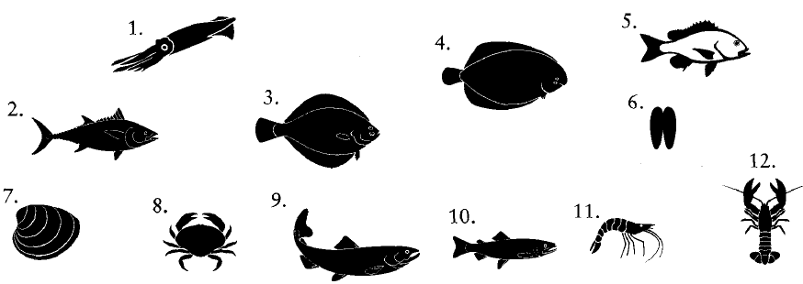

Задание 4. Соотнесите выделенные слова и их определения.
1. Have you had breakfast?
2. What time do you have lunch?
3. What are we having for dinner?
4. Do you wanr some supper?
5. We’ve only got time for a snack.
6. I hope you’ve got a good appetite.
7. I’m starving.
8. We had a barbecue in the back garden.

a. a small meal eaten just before you go to bed
b. the desire for food
c. the meal eaten around midday
d. very hungry
e. the first meal of the day
f. a quick and easy meal
g. when you grill food outside
h. the main evening meal

